Salk Mobile Science Lab
Day 3 – DNA Technology

Recognizing DNA Patterns
1.The technique for separation by size for DNA (or food color) molecules is called ______ _________________.
2. Examine the image of gel under the microscope. What is the importance of its structure?
___________________________________________________________
___________________________________________________________
___________________________________________________________
___________________________________________________________
___________________________________________________________
___________________________________________________________

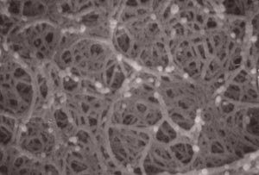

3. Which of the following DNA fragments would you expect to find at the bottom of the gel after the experiment? Why?
Fragment 1 Fragment 2
ATTGC ATTTAGGGGCACGGGACTACATA
_____________________________________________________________________________
_____________________________________________________________________________
4. List 2 reasons why a scientist might use gel electrophoresis.
- ________________________________________________________________________
- ________________________________________________________________________
Color code your gel:
- Draw an arrow outside the “gel” to show which direction electricity is flowing

- Put a star next to the gel to show where the color molecules started

- Draw a circle around the largest color molecule

- Draw a rectangle around the smallest color molecule
.

Analysis
5. Claim: ______________________ is the largest color molecule.
Evidence: (Using your gel as a reference, provide data that supports your claim)
_____________________________________________________________________________
Reasoning: (Write a statement that connects your evidence to your claim about which molecule is the largest)
_____________________________________________________________________________
_____________________________________________________________________________
6. Claim: ______________________ is the smallest color molecule.
Evidence: (How do you know?)
_____________________________________________________________________________
Reasoning: (What is the significance of your evidence?)
_____________________________________________________________________________
_____________________________________________________________________________
Challenge!
What happened to the green food coloring the experiment?
_____________________________________________________________________________
_____________________________________________________________________________
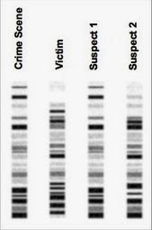
If human genomes are 99.9% similar explain how gel electrophoresis can be used to identify individuals and rule out suspects. Use the diagram on the left to support your answer.
_____________________________________________________
_____________________________________________________
_____________________________________________________
_____________________________________________________
_____________________________________________________
_____________________________________________________

