Salk Mobile Science Lab

Day 2 – Extracting DNA

**DNA: THE MOLECULE OF LIFE**

1. What is the function of DNA? _____________________________________________________

_____________________________________________________________________________

2. Label the diagrams below using the appropriate terms: animal cell, plant cell, bacteria cell, cell wall, cell membrane, nucleus and DNA. Some terms will be used more than once.

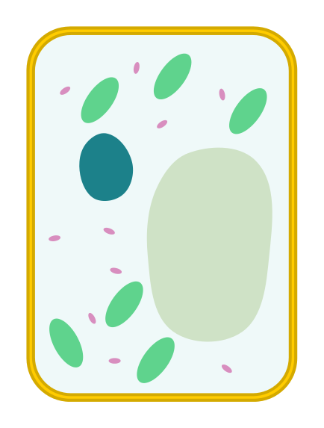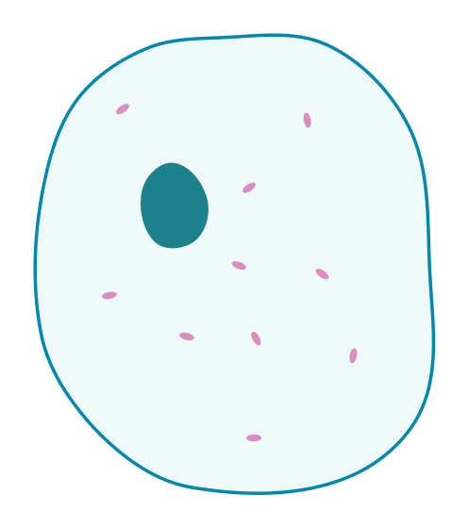

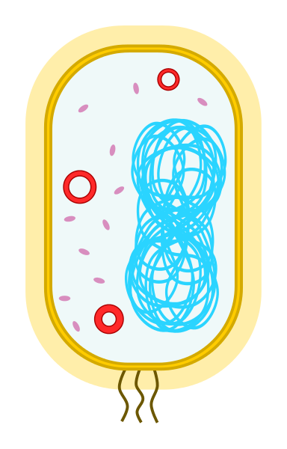

____________________ ____________________ ___________________

3. After the experiment: What color is DNA? ____________________________________________

4. We extracted wheat germ DNA. What color would your DNA be? Explain why.

_____________________________________________________________________________

_____________________________________________________________________________

5. Put terms in the box in order from least complex to most complex:

*Chemical units (T, A, G, C), Chromosome, Genome, Gene*

Simplest Most complex

🡪 🡪 🡪

6. How was today’s activity related to the mutant fruit fly activity?

_____________________________________________________________________________

_____________________________________________________________________________

7. If you wanted to extract the DNA of the fruit flies we examined on the first day would you be able to do the experiment the exact same way? Explain which steps would be the same and which, if any would be different.

_____________________________________________________________________________

_____________________________________________________________________________

_____________________________________________________________________________

_____________________________________________________________________________

8. List 2 reasons scientists would need to do a DNA extraction.

1._______________________________________________________________________

2.______________________________________________________________________