Salk Mobile Science Lab
Day 2 – Extracting DNA

Protocol for DNA extraction from wheat germ
- Our question today is “What color is DNA?”
Write your hypothesis:
IF we extract DNA, THEN the color will be _________________________
- Obtain a numbered 50 ml conical vial with 10 ml of water.
Write your number here:________
- To the tube with 10 ml water add 1g (1 pinch) of raw wheat germ.
- Cap the tube and vigorously shake for about 30 seconds.
Describe what happened to the cell during this step.
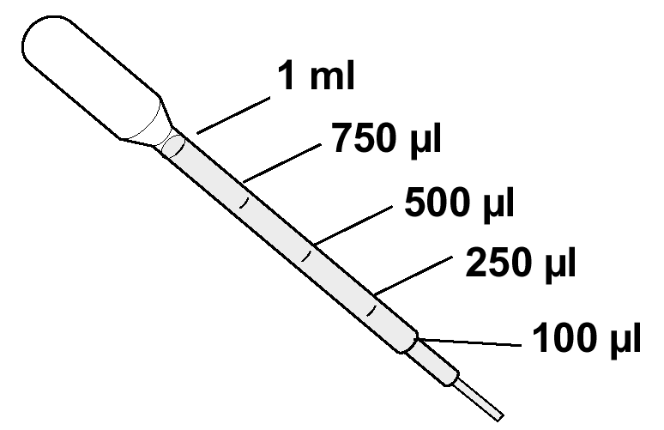
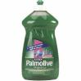
__________________________________________________________
3ml
- Using a transfer pipet, add ~3 ml (one full pipet) of 25% dish soap to the tube with water and wheat germ.
Describe why this step is necessary.
___________________________________________________________
- Cap the tube and slowly tip several times to mix (DO NOT SHAKE). Loosen the cap slightly before placing tube in the hot water bath.
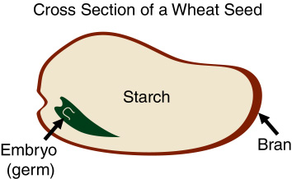
- Heat at 65°C for 5 minutes.
Why does heating the solution help?
_____________________________________________________________
- While the tubes are heating label an eppendorf tube with your initials.
- Before removing your tube from the 65°C water fill a transfer pipet with ~3ml of isopropanol (one full pipet).
- Bring the 50 ml conical tube back to your table and as soon as possible add the pipet of isopropanol to the tube.
- Watch the DNA rise out of the soap layer and into the isopropanol layer.
- After waiting a few moments to allow the DNA to precipitate, remove the DNA using an inoculation loop and place it in your eppendorf tube. Try to avoid any wheat germ debris that is present.
To get more DNA to precipitate you can gently rock the tube. Do not disturb the wheat germ that has settled to the bottom.

