LSRII: Start up and QC, and using the instrument Version 8.3
The following procedures are described in this document for LSRII usage: (1) start up, (2) checking cleanliness (in Diva using QC template), (3) calibration (executing CS&T program), (4) recording mandatory cleaning files every 30min following the cleaning procedure described in this document, and (5) Files/photo proof to be sent to fccf@salk.edu

Before starting, refer to “Where Stuff Is Kept” (map) for location of MQ water carboys, beads, red biohaz collection, sink, etc. To help keep things running and limit damage to instruments accidentally left ON, we have implemented a few changes:

- All user protocols must be reviewed prior to access (if possible, DNAse I treatment must be included to help keep the instrument cleaner). In addition, all samples must be filtered before running on an analyzer
- Instrument is running in MQ H2O instead of PBS for sheath. Cracked FACS Tubes will not hold pressure (will fill up with sheath). Check tubes carefully before installing onto LSRII!
- Return empty carboys to the appropriate pick up location. LSRII-1 (STEM): Empty carboys can be set on the floor beside the LSRII computer desk. LSRII-2 (Parker Rm): Place empty carboys outside the FCCF main door. Autoclaved water carboys can also be collected from here if none are available by either LSRII location.
- Waste tank is to be emptied in the STEM core sink after use (add bleach before reinstalling onto fluidics cart).
- First user of the day: Calibrate laser delays (automated bead QC in Diva) as described in this guide
- RESTART (do not turn off!) the computer when you are done
- When you are done, empty the red trash bag if it is full (do not over fill).
- Send screen grab or photos (MUST BE CLEAR ENOUGH TO READ) of Diva browser showing cleaning files with time stamps, power button OFF, signed clipboard with logged out/restarted monitor to fccf@salk.edu
- As a condition of access, you must send the following items to fccf@salk.edu for review:

  - TAKE A PICTURE of the FLUIDICS PANEL to show STANDBY or OFF. Only leave in STANDBY if you have specifically discussed with the next user (email core, if so). Please send this ASAP so we can confirm the state of the machine.
  - TAKE A PICTURE of the CLIPBOARD (legible, signed off by you) in front of the LOGGED OUT MONITOR SCREEN
  - RECORD FCS FILES AND SCREENSHOT THE BROWSER when performing the 5min cleaning procedure described below every 30 mins
  - ANY REQUIRED QC FILES: (1) Before- and (2) After- bead profiles, (3) CS&T report if it was run

-----------------------------------------------------------------------------------------------------------------------------------------------------------------------

1. Check the sheath tank is full (important for laser delays) – use provided sheath buffer carboys which are now filled with autoclaved MQ water. Check the waste tank is ready to run (1L bleach in bottom). Check that there is bleach available for the waste tank later (grab more if needed from FCCF, inside the entryway). Check that the plastic waste receptacle is seated below the sampling port to catch drips. Cracked FACS Tubes will not hold pressure (will fill up with sheath). Check tubes before installing.
2. Turn on PC and log into workstation. (Optional but recommended LSRII-1: double click on the “Tera Term” icon to launch a communication window. LSRII-2: double click on “Cytometer Status” icon and set it to “Serial”). Turn on LSRII at green power button. Cytometer code should populate the window (e.g. VX Works logo; monitor codes when troubleshooting instrument issues – copy and send to fccf@salk.edu). As the LSRII electronics continue to load, check the sheath filter and release any air bubbles visible to the waste tank (Tip: plug release tubing via its coupler into the spare female port conveniently located at the top of the tank; open the roll valve to purge bubbles before closing valve and uncoupling the tubing). Run 10% bleach in HI for 5min followed by filtered DI water as needed e.g. 5min. *Do NOT use PRIME button: reserve PRIME for troubleshooting, to avoid unintentionally introducing air.

3. Prepare to turn on lasers (read this step entirely before troubleshooting): Follow laser troubleshooting instructions taped to LSRII if needed (also available in the Help Files in Infinity), followed by restarting LSRII, then finally restarting BOTH LSRII and computer (frees up computer RAM used heavily by laser control software). Note that Coherant Connect ties up significant RAM which may cause Diva to be buggy, or laser USB COM ports to be problematic (windows missing in CC). Unless troubleshooting laser issues, after turning lasers ON or OFF, exit CC software (close window) and avoid running it in the background.

- LSRII-1: 4 lasers *should* autofire upon start up from green power button (this model of UV absolutely requires a 2-step process in Coherant Connection (CC) software to start up (1) push the power slider up AND (2) use the Start Button). Open CC and check for 5 laser windows. Follow laser troubleshooting instructions taped to side of instrument if anything is missing (also available in the Help Files in Infinity), followed by restarting LSRII then finally restarting BOTH LSRII and computer (frees up computer RAM). If the UV laser window appears and troubleshooting does not load missing laser windows, skip ahead and proceed at Step (4) to easily confirm if the laser missing is actually on by running CS&T beads (should have peaks in all the detector channels). If the other lasers are producing signals and you DO NOT NEED UV for your experiment, you may be able to proceed with using the instrument with some caution (check that bright bead intensity is as expected and you do not have any shifting/unstable signals indicative of timing calibration issues). If proceeding to use without UV laser on, record a file of the beads in the QC template but DO NOT EXECUTE THE CS&T program in DIVA unless all 5 lasers are ON (very important: or the laser delay timing values will be erroneously set). Coherant Connect is needed to start UV laser on LSRII-1, so use LSRII-2 if issues persist and UV is needed.

- LSRII-2: 4 lasers *should* autofire (no further action needed by user) upon start up from LSRII green power button; the fifth, 561nm, needs to be physically started by the key switch (access panel is located on the front of LSRII, look inside after turning the key and confirm that 2 solid bars are seen on small screen of the 561nm laser controller indicating it is lasing). UV laser takes 15min to stabilize. After initially powering up the LSRII unit at the green button, lasers can be turned on/off in between users to preserve laser life as follows: (1) 561nm at key switch, (2) 488nm using the Stradus software (icon on the desktop: use ONLY the Emission ON/OFF buttons in the software, (see printout on LSRII if settings need to be verified), (3) UV, using UV ON and UV OFF icons on desktop, and (4) 640nm and 405nm lasers using CC software.

Obtain from the fridge: Prepare 1 drop of CS&T beads (black vial with blue label, not the orange vial) into a FACS tube. Labeled: date, “BLUE CS&T” and the Lot ID from vial. Dilute in 300ul filtered DI water from a syringe at LSRII. STEM location: beads are kept in the door of the Media Fridge near the wall mount glove dispenser. Look for the signage on the fridge “ FCCF Beads in Fridge Door (LSRII)”. Parker Room: Fridge is located outside the corridor entryway. Main stocks are in FCCF.
*Beads are expensive, so please protect from light, label and cover with parafilm before returning to the fridge for the next use (please make your best effort to try and re-use beads, however make up new beads if needed to check that CVs are not wide due to using old beads left out in the light. Light will photobleach far red channel signals). If significant “non bead” scatter events are observed, rule out instrument cleanliness issues by checking that a newly filtered tube of water ran the same amount of time has minimal event rate.

4. Close CC then open Diva and log in under Calibration (password bluecst). Open QC experiment located in the Browser. (Cytometer Status window should be displaying the Cytometer IP address at this point; once Diva is opened, it should start loading various hardware boards as it connects to Diva) Make a new specimen for every session and re-label with the format DATE-NAME-LAB-Lot# (e.g. 092820Caz-FCCF-707057). Re-label any tubes you run appropriately e.g. BEFORE (pre-usage record) or AFTER (post-usage record) or AFTER-CLEANING (if you were troubleshooting) etc. If there are issues with the template (e.g. another user deleted gates by accident, or changed the settings), simply load another template to use: *Experiment Menu New Experiment Select DAILYQC template from QC tab*. Run filtered water in LO and ensure event rates are mostly 0-20 events/second (reflecting cleanliness) before proceeding with QC; change the syringe filter if there appears to be significant debris (these should be kept nearby the computer, email FCCF@salk.edu if more are needed). Run diluted beads in LO and start acquiring: example data is stuck on the LSRII (should see 3 peaks in each histogram, see example in Figure 1.). Check to make sure there are no empty plots (missing signals) that indicate a laser is OFF. The scatter plot should not show significant debris events in addition to the beads, if the instrument is clean and beads are made up with clean water. Record a file of the CS&T beads, then on the scatter plot, adjust P1 and P2 around the 2 sizes of singlet bead populations before making a PDF showing the plots and send to fccf@salk.edu. Continue on to the automated CS&T calibration (ONLY if all lasers are on).
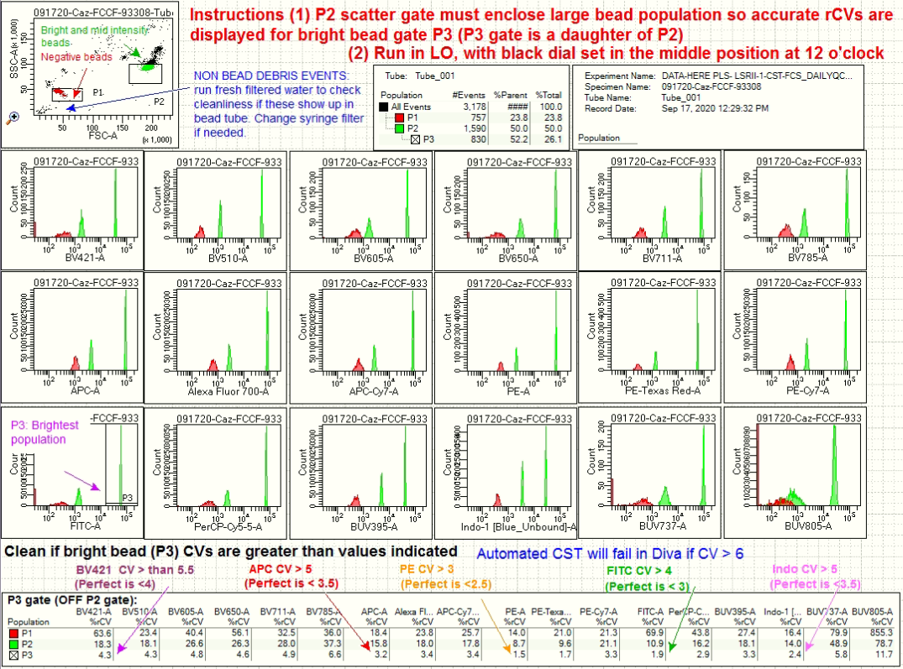

Fig. 1a (Above). Example of CS&T bead profile from LSRII-2. Beads are 2 sizes on the scatter plot and produce 3 peaks of intensity in most channels. Cleanliness can be noted from the scatter plot (no excessive extra events besides beads).
Fig. 1b (Right). (i) Example of excessive “non bead” events that are debris and (ii) elongated/ “strange” side scatter pattern compared to before running samples, indicating possible debris stuck to flow cell: instrument is likely dirty and needing longer cleaning (if instrument has been cleaned and beads still look dirty, check with new beads). Consult with core staff for the next corrective steps needed. |  | i. 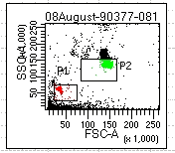 | 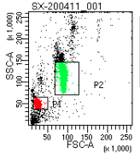ii.
5. IF YOU ARE THE FIRST USER OF THE DAY, execute the CS&T program (read section in entirety before starting): Prepare to start by setting the flow rate to LO with the black dial set in the middle position (LSRII-1 has an updated 1 turn dial, set to 12 o’clock position; LSRII-2 has the original 12 turn dial, set to 12 o’clock at 6 turns). In Diva, go to the Cytometer Menu CS&T. Once connected (monitor the status in bottom right of window; takes a moment to connect) on the right side of the CS&T window, check the appropriate Bead Lot ID# is highlighted (select a new lot# from the middle pane drop down menu if not already automatically highlighted). If your bead lot is not available, proceed any way; choose one to use as you can still successfully calibrate the laser timing (notify staff later) select Performance Check > Run button from the “Characterize” drop down menu. Follow prompt to load beads etc. Note that while the CS&T mode is open, Diva interface is disconnected (will be indicated in bottom left of Diva screen that it is in CS&T mode). *Important*: CS&T will time out and fail (gives an error message) if beads are too dilute, and we have observed that the vial dispenses less beads when it is nearly empty. If bead volume permits, the process can be expedited by running the first two steps of the CS&T process in MED, however remember to keep an eye on bead volume so it does not run out, especially if you have had to run the beads a few times ahead of this step. If the bead volume looks dangerously low while running the CS&T program, it is possible to quickly remove the tube to add a second drop of beads, re-suspend and reinstall the tube without causing the program to fail), however at Step (3) Cytometer Set Up, you MUST set the flow rate to LO with the black dial set in the middle position to ensure the lowest bright bead CV values are obtained by Diva (so CS&T does not fail). Example of a report is shown in Figure 2. Check the report when completed (e.g. scroll through both pages) if it passes with warnings, or fails, try more cleaning cycles (especially if instrument hasn’t been used in a while) and repeating CS&T. If this does not resolve the issue, close CS&T to return to Diva: open the QC template and check again how beads look, if peaks are well resolved (check for example taped to LSRII) it is probably good to use cautiously (check with core staff if needed) as imperfections with beads may not show up when running biological samples. Typical issues on the report are wider than acceptable CVs, meaning that the instrument needs cleaning or running water longer. Reports are organized on the left side of the CS&T Screen (in the Reports Tab). Export a PDF (locate the report and right click on it) to send to fccf@salk.edu. Close CS&T when done. Always choose “Use Cytometer Settings” any time the message pops up.

Fig. 2 (Below, left and right). 2 page CS&T report generated in Diva. Pass/Fail is indicated in the header of page one; if CS&T fails then report will highlight in red the out-of-specification value. Wide CVs or large positive gains in PMT voltage are indicators that instrument may be dirty. Calibrated Laser Delays are indicated at the end of the second report.
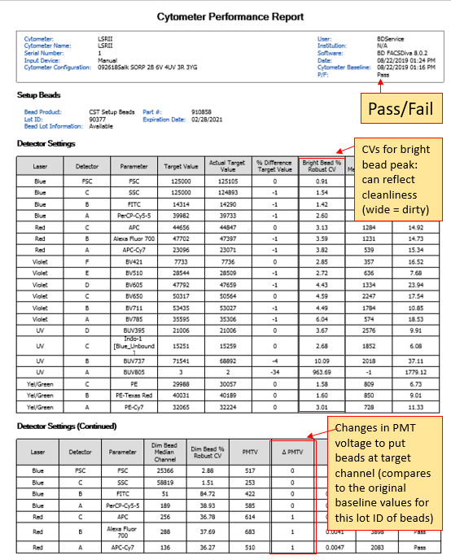 | 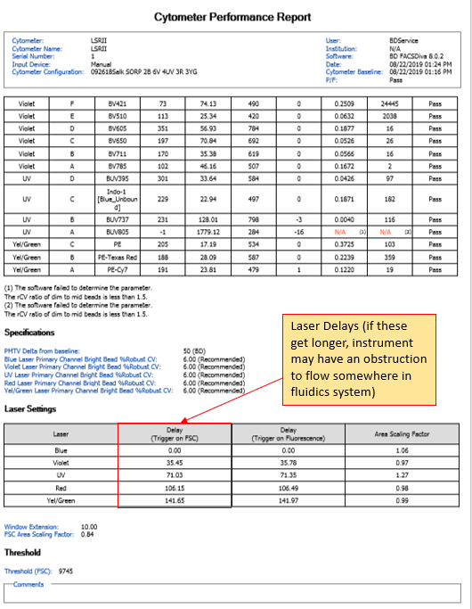

6. Log out of Diva Calibration username and log back in with your own Diva account to prepare for running samples.
- If you are having issues running samples, open the QC template and check how beads look (compare with example below)
- If you have issues seeing signals after QC passed, we have seen template (experiment) corruptions where laser delays are not up to date (so specific laser signals may appear to be absent when you run samples). Timing values for each laser can be verified as follows: (1) the most recent CS&T calibration report contains the correct values on pg2, compare these timing values to (2) laser delays being used in an open Experiment – check Experiment associated delay values by looking in the Laser tab of the Cytometer Window. If an experiment does not display the calibrated laser delay values, it is best to start over fresh: Copy your detector voltages from that experiment (eg screen grab), make a new experiment (to update the laser delays) and type the detector voltages in.
7. Remove beads and run water while getting set up for your experiment. Record cleaning files ≤30min as detailed below and take a photo of Diva browser showing time stamps when finished using LSRII (send to fccf@salk.edu):

Every 30min (or less!), clean and record files of each cleaning reagents to use the timer in Diva:

2min CLEAN (10% Bleach) with 3-5 PRIME cycles interspersed:
When doing the PRIME, remove the tube first and keep SIT arm to the side: Hit the PRIME button and look for movement of waste through the waste tubing (this indicates the Flow Cell has been emptied out). Instead of waiting for the LSRII to return to STANDBY, hit RUN (doing this causes the Flow Cell to fill quickly for better agitation). After PRIME cycle, install tube and keep running.

2min RINSE (5% Contrad detergent) with 3-5 PRIME cycles interspersed
Do the PRIMES as above (no tube/SIT arm open, hitting RUN when Flow Cell is emptied).

1min H₂0 2x PRIME cycles. Do the PRIME cycles (no tube/SIT arm open) at the start only, run water after for 1min
The event rate running water must be low 0-20evt/s in Diva (make new filtered water to check if event rate is high).

8. Final Cleaning and shutdown/standby: After running samples, follow clipboard checklist (i.e. perform thorough post-use cleaning while recording cleaning files to use the timer). Under the Calibration log in: Record/create an “after” use bead PDF (Calibration log in) to demonstrate cleanliness before finishing up at the machine. Take a photo of the fluidics panel showing status (e.g. OFF = no lights) before leaving: Leave no more than 1mL of H₂O in the tube on the SIT. Clean longer if instrument has unacceptable CV values or scatter indicates instrument is dirty, email the core if you have issues with getting the instrument clean (you may be requested to assist with execution of extended cleaning procedures the following day if needed, if the instrument is dirty following your usage). Submit files and photos to fccf@salk.edu: (1) CS&T beads PDF (2) CS&T Report PDF if executed (3) Photo proof of cleaning files and (4) Photo proof of clipboard checklist items (follow each step!) signed, with the Fluidics panel.

9. Restart the PC as the last step before you leave (do not shut down, only RESTART): to reset/free up computer RAM.

10. Empty/change the red biohaz trash bin if full: Double bag, do not twist bag neck (steam access will be limited) – scrunch it in your fist and secure with autoclave tape. Deposit in large round red biohaz collection tub. Install 2 new bags (See Help File “Where Stuff is Kept” for map for info for FCCF and STEM if needed).

LSRII Quick Start Guide *Download a copy of this instrument Help File: salk.edu/fccfaccess > Help Files
*18 fluorescence channels (355nm, 405nm, 488nm, 561nm, 640nm lines) See chart on side of LSRII for filter/detectors
Check Tanks | Sheath Carboy: Sheath is MQ H₂O. Refill at end of session! Depressurize to open, fill to weld line (use autoclaved water carboy) Waste Tank: previous user empties and adds 1L bleach ready to use
Log into PC, open Cytometer Status | Salk Active Directory credentials (contact IT Helpdesk for log in issues). DO NOT FORGET TO RESTART PC WHEN DONE (do not turn off!). Open Cytometer Status icon on desktop and leave open > Copy codes from here as text to send the core including any codes if you experience error messages in Diva. This window displays Cytometer IP address when LSR is ready for Diva
Power Button | Green Button, front. DO NOT FORGET TO TURN OFF (you will be charged time)
Remove air | Purge Air from 0.2um Filter to prevent spurious data
Prime and Clean | Prime system 2-3 times (should see bubbles), run water 5min while setting up. RUN button should turn green, if yellow check the sheath tank (lid o-ring and pressure gauge), check quick release connectors on sheath and waste tanks (eg waste line going into the top of the waste tank), and also check for a cracked FACS tube.
5-Lasers: Turn ON  (if first user).  ~15min warm up for LSRII-2 UV: UV bright peak ~ 10^5 when ready) | LSRII-1: For 4 lasers, no action is needed. Need only start UV using Coherent Connect (slider plus START button). *Close Coherent Connect when not actively turning on/off. Do not leave running in the background.  LSRII-2: For 3 lasers, no action needed. Start 2 key switch controllers in front access panel according to instructions taped inside. UV must show 2 solid LED lights after turning key: re-start at key if blinking (turn off, wait 5s, turn on). 568nm must have 2 solid bars on display screen when laser key is turned (reset key if needed).
Log into Diva | Calibration (pw: bluecst) for QC, or your log in from user training (typically same as AD log in)
Bead QC (“before”) | *First User: check bead CVs in template THEN execute automated CS&T. Update mini notice board on LSRII if this was completed by you. Optional for following users: check bead CVs. New users: Make PDFs to send
Prepare to run samples  Log into Diva with your user account  Intermittently clean (5min process) to ensure high quality data | - Use BD polystyrene FACS tubes, check tubes for cracks before running (otherwise tube will fill up).  - Filter samples: MUST be free from clumps or viscous material to prevent clogs  - Fluidics control panel is on front of LSRII: RUN button goes green when pressurized (if YELLOW: check tank pressure gauge, check o-ring of sheath tank lid hasn’t fallen inside tank. Also check the sample tube for cracks.  - Tube “support” is adjustable by rotating however it should not be necessary to “hold” the FACS tube on – if tubes are falling off, notify staff to replace bal-seal (holds tubes on). Never close the support arm with no tube.  - Refer to Diva user training guide located by the instrument to get started if needed  - Never use DUPLICATE WITHOUT DATA, and make use of properly exported experiment templates (ask us!)  - Intermittent 5min cleaning: (Optional, but recommended) Every 30-60min (with PRIME, as per Usage Guide)  - Running more than 50 tubes: split into another specimen after 50 tubes to avoid Diva issues  - Running large files: split into several files to avoid Diva issues (can concatenate in Flowjo later)  - Expedite recording: set Diva to show less events while recording to allow faster processing. Delete any extra plots.
Troubleshooting: Clogged Sample Injection Tube (SIT).  Avoid at all costs! | Signs include: Event rate dropping, no events, NO BUBBLES WHEN PRIMING, or even simply “weird” looking scatter plot data could be a clog. Avoid by (1) filtering samples and visually checking samples before running, (2) running bleach and water periodically during your session if collecting sticky samples (eg tumor derived) and (3) using DNAse (needs MgCl₂ to work) in your protocol/buffers for samples with dead cells or tissue derived samples (tumor, intestine, brain etc). *Do not attempt to run the sample if mucous consistency material is seen. If a clog occurs, try the cleaning stylus (remember to put a small kink in end to hold on to), and Prime (button on fluidics panel) function to try and clear blocked sample injection tube (SIT). Perform cleaning (see Usage Guide)
Troubleshooting: Unstable signals, visually “drifting up and down” | Typically green laser or red laser (most affected as these are the last two lasers): Check for air in sheath filter, then as a precaution, perform air removal at Flow Cell > Run an empty tube and watch for bubbles to come through to the waste line (the clear tubing that goes to waste tank), when bubbles appear switch to H₂O for 5min. Afterwards, execute automated CS&T to recalibrate the laser delay timing values.
Troubleshooting: No signals in your experiment | (1) Run a tube of water > Hit PRIME and check for bubbles in the FACS tube: This is to check for a clogged SIT (see section above). (2) Check for events in Diva on a scatter plot (Acquire > Hit PRIME). If there are no events at all but there is bubbling during PRIME > Check beads in QC template. 488nm laser (e.g. FSC, SSC, FITC signal), MUST be on to trigger electronics or no events will show > Restart LSRII if needed. (3) If specific lasers are missing signals but the QC template can read and show bead signals fine, your experiment may be corrupted so start fresh > Snip tool (or copy) the PMT voltages and type them into a brand new experiment. Try executing CS&T after a re-start.
Clean LSRII /Bead QC (“after”) | Cleaning and tank maintenance instructions on clipboard, sign off at each step. Optional: Record bead profile in QC template. *New users: check beads in QC template and make PDF for first few sessions until signed off by FCCF.
Export Data | Right click on the experiment in the browser recommend to (1) “Export Experiment” first (browse, locate to Desktop) then repeat a second time choosing (2) “Export FCS Files” (choose FCS3) browse, locate to Desktop) “replace all” FCS files. This gives you a folder with your template as well as correctly names data files.
Connect to Filer | Go to “Computer”. If need to map to Lab share: Right click Computer and select map network drive. Type in path and lab, e.g. \\filer.ad.salk.edu\IMPL-K (*your lab)
Delete old data | In the browser: Right Click Delete (Important: Prevents Diva getting buggy and slow!)
How to leave LSRII: | If you are not the last user: leave lasers on, instrument in STANDBY (with less than 1ml water). Last user: (1) Turn off lasers (basically the reverse of how you turned them on), (2) POWER OFF at green button and (3) RESTART PC (4) DEPRESSURIZE the sheath tank completely when LSRII is OFF: this is to minimize air bubbles forming over night.
Email photos/PDFs | Take photo of FLUIDICS PANEL (in OFF or STANDBY), with legible clipboard signed off > Send to fccf@salk.edu and next user for the day (check schedule). New users: send bead profiles for first sessions until signed off by FCCF.

