Flow Cytometry Core Facility – Fusion V.6 Email completed form to fccf@salk.edu to get access to Fusion

Conditions and Acknowledgement form for use of instrument. Please read through and initial the boxes next to each section once you have read and understand what is required. If you have questions, ask them before sending in your initialed and filled out acknowledgment form.

- Coming to the core: Please access the Fusion “niche” via the West entry way of FCCF unless locked (if locked, come via the main card entry door). This is to reduce traffic through the core.
- Buffer time between users: 1hr between users to allow for clean up and unexpected issues (e.g. nozzle clog)
- After your training session: While still fresh in your mind, arrange to come to do a practice start up (e.g. on a day there is a sort later: come by and do the start up while staff are available to answer questions). We do not charge for follow up “practice” if there is one scheduled later that day. Be sure to confirm with staff if that is a good day to come in case you need more help than anticipated. Your first autonomous session: Best to plan for M-F during the day, ask staff when you should book your session (we will find an appropriate time, in case you need help). Allow extra time to run the QC if you are the first user.
- Only one person at an instrument unless pre-approved by core.
- LCMV/patient sample sorting: Check with core first as anyone working in area must be notified. Be sure to ask staff to go over usage of the AMS (Aerosol Management System) and follow the general safety precautions for BSL2+ sorting on the Fusion (download from Help Files).
- Always check the calendar before going to the lab: be 100% aware of who is working especially if you are jumping in on short notice ahead of a user – obtain their permission first if there is any chance you are running late and could be present when they come to use the instrument.
- Changing to another instrument: Make a new calendar booking on the instrument you are using for contact tracing (inform the core if you need cancellation help on the original booking).
- Sorters use autoclaved 1x PBS located in ergonomic rectangular carboys. This is made up from Cheap Sheath concentrate and MQ water.
- Instrument operation is subject to new usage instructions uploaded on Salkland.
- You may be asked to help execute an extended cleaning protocol if the post use QC shows it is needed.
- No drop ins, bookings/appointments only: Email fccf@salk.edu
- COMMUNICATE with each other by email, especially if you are delayed on an instrument.
- Enable wifi calling to use cell phone in the basement areas (FCCF or STEM)
- Access requires protocol review by FCCF (if running cells, these must be treated with DNAse I – see the Help File on Salkland.edu/fccfaccess for more info). Please send over your protocol for review along with this form.
- Sign up for Fusion-Users mailing list for updates on instrument protocols, repairs, and any other relevant information regarding the usage and health of the Aria Fusion Sorter. You can do this by visiting http://lists.salk.edu/mailman/listinfo/fusion-users , filling out the information in the Subscribing to Fusion-Users section, then hitting the “subscribe” button at the bottom of the section.

Name: | Lab: | Cell phone:
My protocol has been approved by FCCF (steps indicating use of DNASe I: e.g. which step, and how much)
I know which door to use during regular hours (i.e. NOT THE MAIN FCCF DOOR).
I have already located all relevant instrument Help Files in Salkland and read them
I know where to locate more: Bleach (by door in FCCF, more in Parker Rm), CS&T and Accudrop beads (in FCCF fridge door), and Autoclaved sheath carboys (if not nearby within the core, check for autoclaved carboys delivered by Salk Glass-wash staff to the corridor area immediately outside FCCF’s main door).
I understand that sorter sheath buffer is autoclaved 1x PBS made up from Cheap Sheath concentrate (bottles are located in the core, dilute with MQ water), and are kept in RECTANGULAR carboys located in the core or outside the main FCCF door.
If there’s at least half a carboy leftover sheath and it is Sunday- Thursday, then I will place fresh autoclave tape on the carboy and place on the cart outside FCCF (Salk Glasswash service runs on week days, collecting carboys early in the morning).
I will put rinsed empty bleach bottles into recycling, and change the red bio trash bag if full
Refer to Fusion Quick Guide Start Up Section
I understand how to do the following when starting up the Fusion:
- Check fluid levels of sheath and waste tank
- I understand that ethanol changeover may be needed, and I know how to perform this
- I know to turn on the PC, Fusion, Waterbath, Compressor AND the AMS and BSC fan
- I know that the Waterbath requires two steps to turn on
- I know to open Tera Term and Coherent Connect and know how to troubleshoot if a laser is missing from CC
- I know that starting the UV laser is a two step process
- I know to EXIT Coherent Connect window once I’ve started all 5 lasers
- I know when to open DIVA (When Cytometer IP address is displayed in Tera Term)
- Once Diva is open, I know to select “Use CST Settings”
- I know that Fluidics Start Up must be performed before starting stream and I know how to check this status
- I know what nozzle I need for my sort and what configuration goes with that nozzle
- I know how to clean and dry the voltage plates and sort block, and how to install the correct nozzle for my sort
- I know to purge sheath filter of air and know to do this carefully (with care not to take the cap entirely off or lose it)
- I know to adjust stream break off my adjusting amplitude and nothing else!
Refer to Fusion Quick Guide Running Calibration Procedures Section
- I know to run CS&T through automated CS&T program if I am the first user of the day
- I know how to check the CST bead profile histograms within the QC template
- I know to generate PDFs for the CS&T (if first user) and bead profile histograms and email these before sort PDFs to FCCF core staff at FCCF@salk.edu
- I know that sweet spot must be on in order to run Auto-Delay (and to sort!)
Refer to Fusion Quick Guide Sorting Section
- I know which sort device to select and how to target the side streams into the collection tubes
- I know to make a new experiment or load a template from experiment menu > new experiment AND NOT to duplicate an old experiment as it may corrupt diva.
- I understand that my samples must be filtered before running on the sorter
- I know to set up anydesk if I choose to remotely monitor my sort
- I know that mid sort cleaning may be necessary depending on my sort, sample quality, event rate dropping etc…
- If the nozzle clogs, I know to:
  - STOP THE STREAM
  - SWITCH AMS TO HI for 5 minutes
  - Remove nozzle and sonicate, clean and dry inside sort block, then follow remainder steps to resume sort
Refer to Fusion Quick Guide Cleaning and Shutting Down Section
- I will clean the fusion adequately post my sort for the next user or prior to shutting the instrument down
- I will record post cleaning CST bead profile histograms after sorting and send this to FCCF@salk.edu directly after my sort
- I know to export my data and delete my old experiments (old experiments slow down DIVA!)
- I know to leave the laser interlock door open after I have finished sorting and between users
- I know to leave the stream off after cleaning if there is a long break before the next user AND that I would install CLN and preform a flow cell clean with 1.5% Citranox
- I know how to perform a “Flow Cell Soak” if need be
- I know when to do a “Regular Shutdown” and when to perform an “Ethanol Shutdown”
- I will check the sort schedule so that I know what conditions to leave the sorter in after I have finished my sort (On for next user OR Regular Shutdown OR Ethanol Shutdown)
- I know to Power off/take pics/send pics to FCCF@salk.edu of proof that I’ve turned off or done the following:
  - BSC fan
  - BSC light
  - AMS
  - Green power button OFF on Fusion
  - Waterbath OFF
  - Compressor OFF
  - Filled out the Clipboard

Photo Examples
Emailing items 1, 3, and 4 (unless specifically directed otherwise) is a condition of your access to the core’s autonomous use instrumentation. Item 2 is required if you are the first user of the day.

- CST Beads Profile PDF (Pre-running samples):
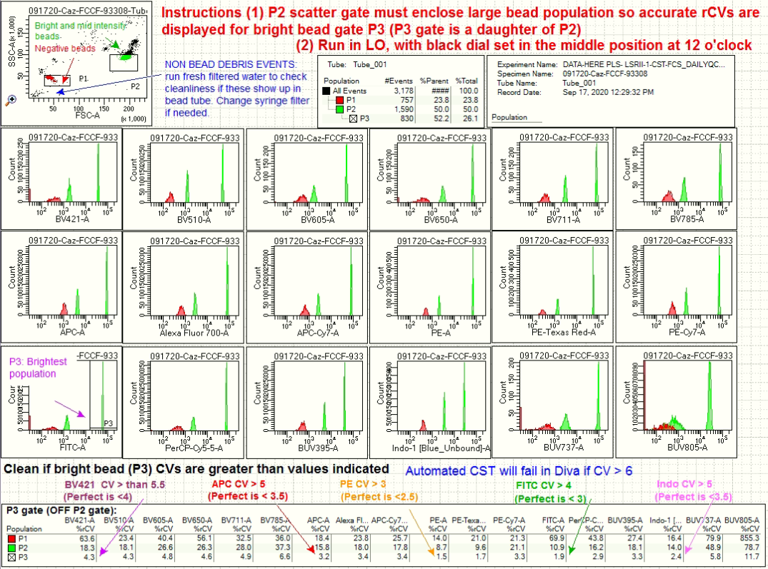

- CS&T Report PDF (2 pages): required if you are the first user of the day.
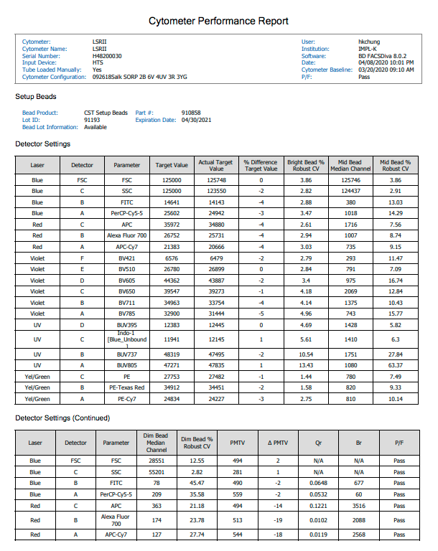

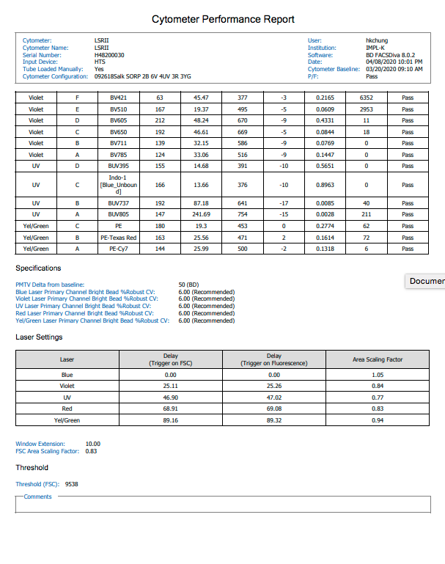

- CST Beads PDF (post-running samples, post final round of cleaning):

- Clipboard checklist items, signed (legible), with fluidics panel OFF in the background:
