Flow Cytometry Core Facility – A3 V2 Email completed form to fccf@salk.edu for scheduling access

Conditions and Acknowledgement form for use. Read also Usage Guide on Salkland salk.edu/fccfaccess > Help Files

- FCCF has analyzers in 2 places: “Parker Room” (A3/LSRII-2/MACSQuant/Canto) or “STEM” (LSRII-1) that can be booked concurrently (are more than 6 feet apart).
- Buffer time between users: 30min between users to allow for clean up and unexpected issues
- Instrument operation is subject to new usage instructions available on Salkland: salk.edu/fccfaccess > Help Files
- Your first autonomous session: Plan to come M-Th during the day, and ask staff when you should book your session (we will find a good time for you to book, in case you need help). Book extra time to learn how run the QC.
- Parker Room occupancy: Maintain 6ft distance while in room (priority given to instrument operators).
- Only one person at an instrument unless pre-approved by core. Any time you bring a co-worker, please indicate their attendance/name on the Logsheet (for contact tracing).
- Always check the calendar before going to the lab: be 100% aware of who is working especially if you are jumping in on short notice ahead of a user – obtain their permission first if there is any chance you are running late and could be present when they come to use the instrument.
- Changing to another instrument: Make a new calendar booking on the instrument you are using for contact tracing (inform the core if you need cancellation help on the original booking).
- Analyzers are running autoclaved MQ water (instead of PBS) as sheath at this time
- You may be asked to execute an extended cleaning protocol if the post use QC shows it is needed
- No drop ins, bookings/appointments only: You must reserve a session on Infinity BEFORE using the machine. Your first autonomous session: Plan to come M-Th during the day, and book extra time to learn how run the QC; ask staff when you should book your session in case you need help.
- COMMUNICATE with each other by email, especially if you are delayed on an instrument
- Enable wifi calling to use cell phone in the basement areas (FCCF or STEM)
- Access requires protocol review by FCCF (for inclusion of DNAse I: which steps/how much). Please send over your protocol for review along with this form.
- Unclogging the instrument: You will need to demonstrate to staff that you know how to insert the cleaning stylus wire for both types of clog scenarios. Full obstruction: no events displayed, nothing taken up from tube and Prime button does not generate bubbles; partial obstruction: weird looking scatter pattern with sample and with beads, event rate fluctuates (clumpy sample).
- Sign up for A3-Users mailing list for updates on instrument protocols, repairs, and any other relevant information regarding the usage and health of the A3. You can do this by visiting http://lists.salk.edu/mailman/listinfo/a3-users , filling out the information in the Subscribing to A3-Users section, then hitting the “subscribe” button at the bottom of the section.

Name: | Lab: | Cell phone:
My protocol has been approved by FCCF (steps indicating use of DNASe I: e.g. which step, and how much)
I understand the A3 runs on buffer with surfactant and will fill tank using the labeled carboys located by the A3
I understand the A3 runs on buffer with surfactant and will check with FCCF staff regarding sensitive live cell assays.
I will perform tank maintenance if there is 3L or less sheath / 7L or more waste.
I am aware of the two audible alarms (sheath and waste) and troubleshooting steps if the waste alarms erroneously
I know how to locate instrument related documents (eg extra troubleshooting SOPS ) on Salkland at salk.edu/fccfaccess > Help Files (a desktop link is provided on the A3 workstation).
I know where to locate more: Bleach (by door in FCCF), CS&T beads in STEM, Parker Room (or in FCCF), and MQ water sheath carboys (if not nearby, autoclaved carboys are delivered by Salk Glass-wash staff to the corridor area immediately outside FCCF’s main door)
I will put rinsed empty bleach bottles into recycling, and change the red bio trash bag if full
I understand how, and will purge the sheath filter of air before I commence usage
I understand how to trouble-shoot for missing lasers according to instructions (e.g. in Help Files):
(i) FCCF staff have already set up Coherent Connect (CC) for me during training to show only the UV laser
(ii) I am aware that a troubleshooting procedure for Coherent Connect will be located in Help Files for the A3
(iii) I understand that I can check that a laser is ON by running beads in the QC template (Calibration login) if there are issues with a laser I do not need, I CAN proceed to use the instrument
(v) I will exit Coherant Connect after turning ON/OFF to avoid lasers turned off randomly
(vi) I am able to turn on the UV laser (it requires both the power slider as well as the START button in CC!!)
I will log into Diva under Calibration (pw =bluecst) to look at CST bead profiles and make PDFs
I will check instrument cleanliness first, before running beads, looking for low event rate (fluctuating as low as 0-20evt/s when very clean, less than 50-100 evts/s) with freshly filtered water.
I will change the syringe filter if I see high event rate for water, and will re-check before using to make up beads
If I am the first user of the day, I will execute the automated calibration and export a PDF to send to fccf@salk.edu
I will produce a “before” bead profile PDF if (1) I’m the first user of the day or (2) a user immediately running before me on the same day has not left an acceptable “after” file in the Calibration log in (that will suffice as “before” bead data for me). I will always produce an “after” bead profile following cleaning up, to demonstrate the LSRII is clean.
I will run the automated CS&T program if I am the first user (or if I am troubleshooting a problem), and:
(i) I will NOT run the program UNLESS ALL 5 LASERS ARE ON (detectors have peaks in all histograms)
(ii) I am aware that the program will time out (and give error messages) if the beads are too dilute
(iii) Beads are $$, I will put the diluted/labelled bead tube back in the fridge so they can possibly be used again
I understand that unstable/shifting signals (eg green laser on LSRII-1) is something I can probably fix by:
(i) First purging any air from the sheath filter
(ii) Second, removing at the flow cell: run an empty tube as soon as bubbles appear in the waste line (tubing that runs to the top of the waste tank) run water 5min
(iii) Executing the automated CS&T to calibrate the laser delay values now that air has been purged
I have accessed Help Files in Infinity and read the Usage Guide; I will comply with:
(i)“5min cleaning” as described every 30min use (or less) if my samples prove difficult to clean up after
(ii) Recording cleaning files from the 5min cleaning for (a) bleach, (b) rinse and (c) water.
- Checking after use for cleanliness according to instructions, or staff directions
(iii) Submitting screengrab proof (eg Diva Browser with time stamps)
I will read and will perform every step and sign off the clipboard after use:
(i) Tank (Sheath & Waste) maintenance
(ii) Data backup I will delete my previous session’s data to help maintain Diva database at less than 4gb
(iv) Instrument OFF I will take photo of fluidics panel, together with clipboard
(v) I understand that ONLY A PHOTO OF THE FLUIDICS PANEL IS ACCEPTABLE for (iv)
I will restart the PC before I leave (restart, NOT shut down)
MANDATORY: Before leaving, I will send a Photo of signed clipboard with instrument fluidics panel showing how I left it (eg OFF) to the next user on the schedule (if there is one) and fccf@salk.edu.
I will perform corrective maintenance (long cleaning) under staff directions if needed
I understand that “Duplicate without Data” is NOT TO BE USED as it can break DIVA database; I will ask FCCF staff how to correctly re-use instrument settings (i.e. I will load templates correctly, from the Experiment Menu)
I understand that Diva is periodically reinstalled (due to database issues) and I may need to make myself a new account using the provided instructions by the LSRII at my next returning session if I cannot log in to Diva
I understand what a full vs a partial clog looks like and have demonstrated to staff I can insert a cleaning wire
I shall ensure a tube with NO MORE than 1mL of H₂O is installed on the instrument before putting in STANDBY or OFF
New instructions may require another form to acknowledge my reading and understanding

Good Examples of What You Are REQUIRED to Send to FCCF@salk.edu DIRECTLY AFTER Using an Instrument.

Emailing items 3, 4, and 5 (unless specifically directed otherwise) is a condition of your access to the core’s autonomous use instrumentation. Item 1 is required if the user before you does not have an acceptable “before” beads in the Calibration account. Item 2 is required if you are the first user of the day.

- CST Beads Profile PDF (Pre-running samples): required if the user before you does not have an acceptable “before” beads in the Calibration account.
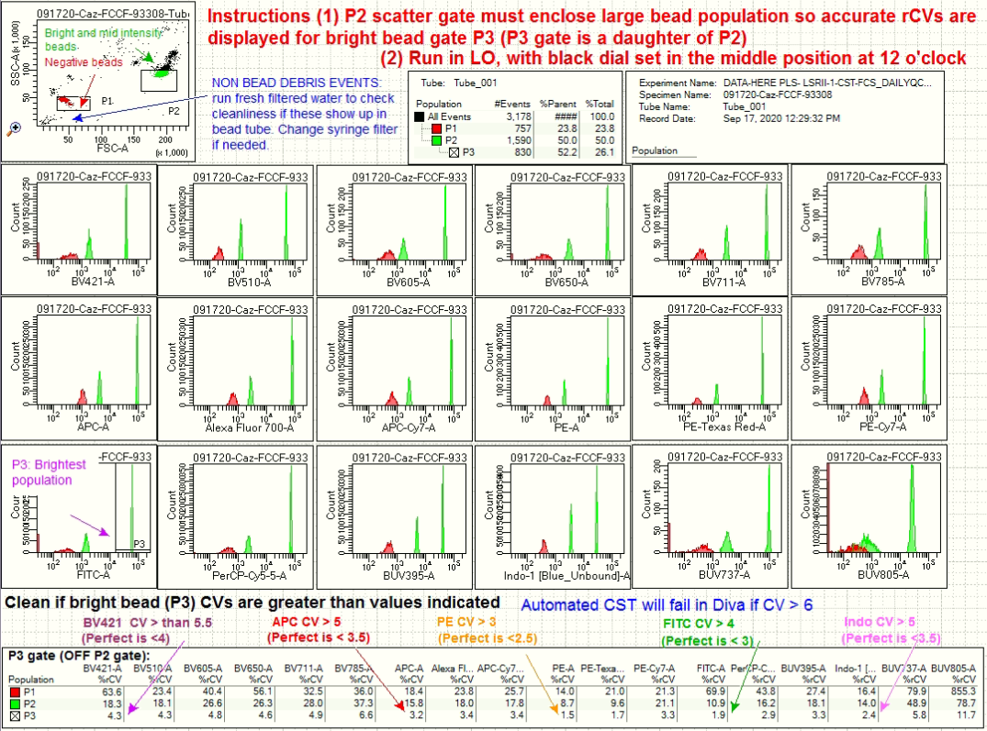

- CS&T Report PDF (2 pages): required if you are the first user of the day.

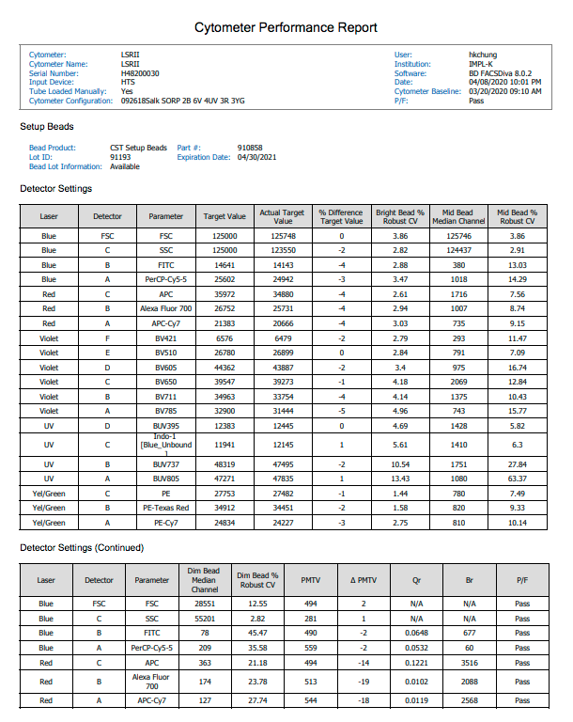

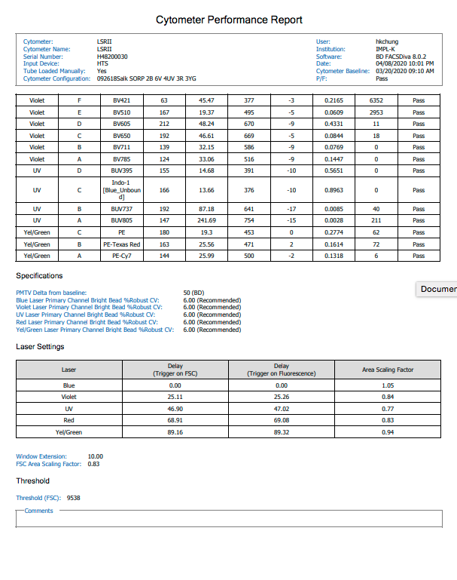

- Cleaning Files: Screen grab with Time Stamps

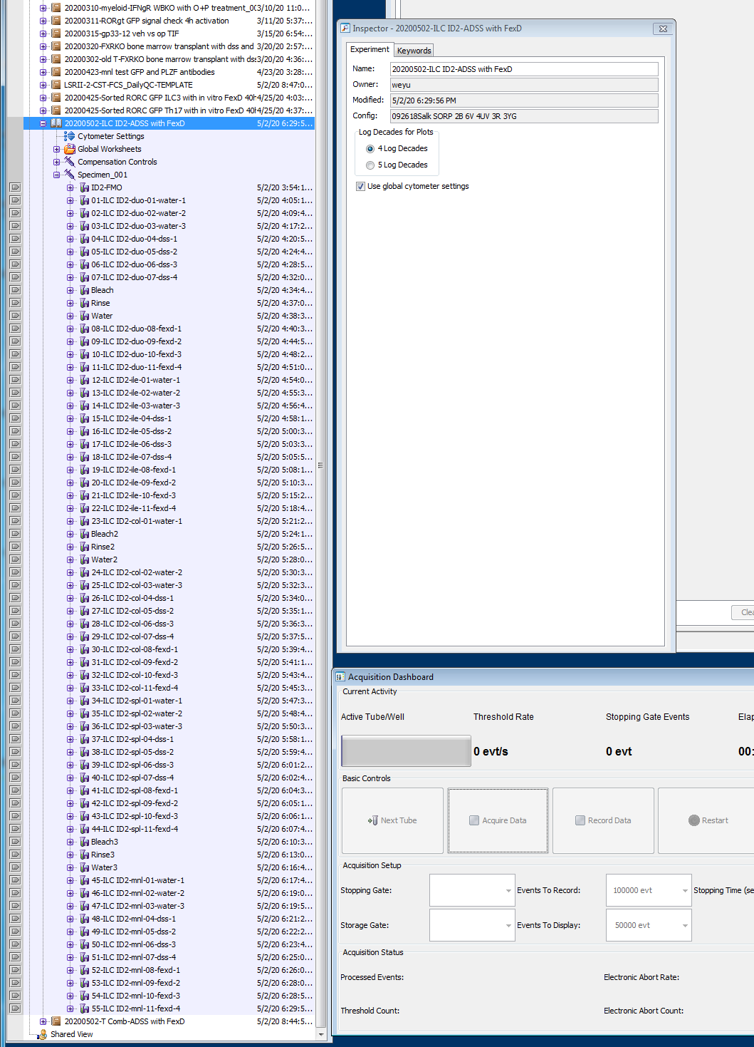

- CST Beads PDF (post-running samples, post final round of cleaning):

- Clipboard checklist items, signed (legible), with fluidics panel OFF in the background:
